**Project Design Phase-II**

**Data Flow Diagram &User Stories**

|  |  |
| --- | --- |
| TEAM ID | PNT2022TMID07381 |
| TITLE | Personal Assistance for Seniors Who Are Self-Reliant |
| DATE | 18/11/2022 |

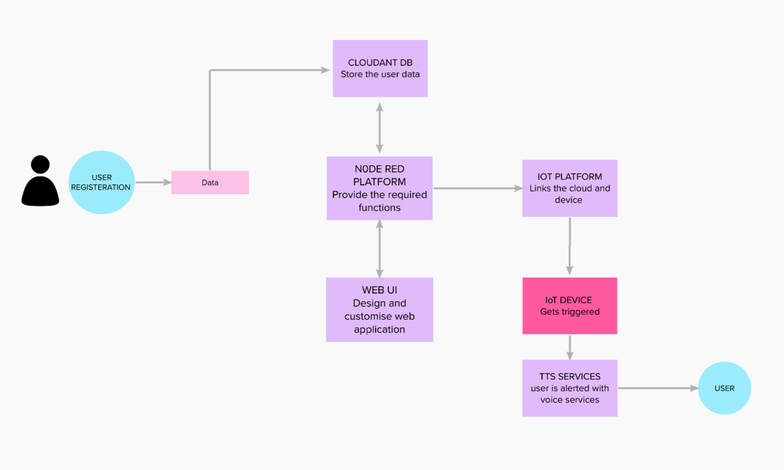

**DATA FLOW DIAGRAM**

**USER STORIES:**

Use the below template to list all the user stories for the product.

|  |  |  |  |  |  |  |
| --- | --- | --- | --- | --- | --- | --- |
| **User Type** | **Functional**  **Requirement**  **(Epic)** | **User**  **Story**  **Number** | **User Story / Task** | **Acceptance**  **criteria** | **Priority** | **Release** |
| Customer (Senior user) | caretaker | USN-1 | As a user, I want to take Medicines on time and monitor my health | I want to take medicines on time | High | Sprint-1 |
| Customer  (Diabetes  Patient) | Smart medicine box | USN-2 | As a user, I want to take my  tablets on time by voice command | I want to take my tablets on time by voice command | High | Sprint-1 |
| Customer  (Thyroid  Patient) | Smart medicine box | USN-3 | As a user, my patient needs to take medicines on time and monitoring the activity | My patient needs to take medicines on time | Medium | Sprint-2 |
| Customer  (Coma  Patient ) | Caretaker | USN-4 | As a user, my patient needs medication time and prescription should load indatabase for upcoming week | My patient medication time and prescription should be in database list | low | Sprint-4 |
| Customer (Disabled  People’s) | Smart medicinebox | USN-5 | As a user ,i need to take my medicine in nearby places with  light notification | I need to take my medicine in nearby places with light notification | Medium | Sprint-3 |